Activity 5 Title:
Building and Integrating a Laravel Application with APIs
Name: Ruby Janne M. Batiancila BSIT 3B Date: 04/27/26

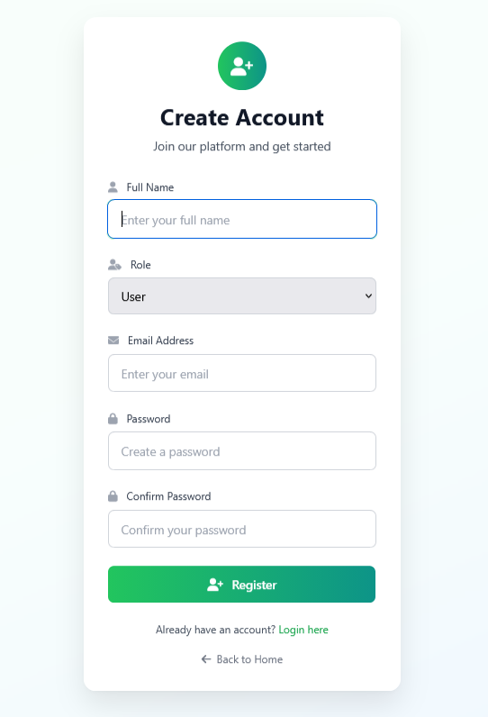
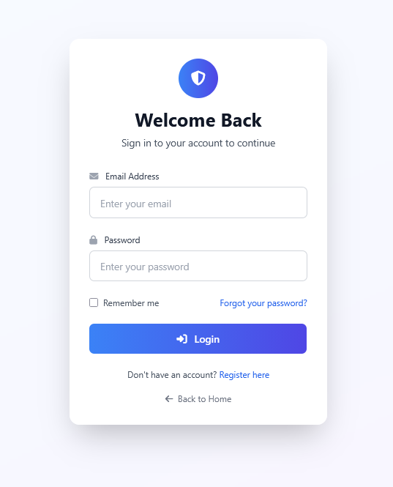
Log in/Register

User Dashboard
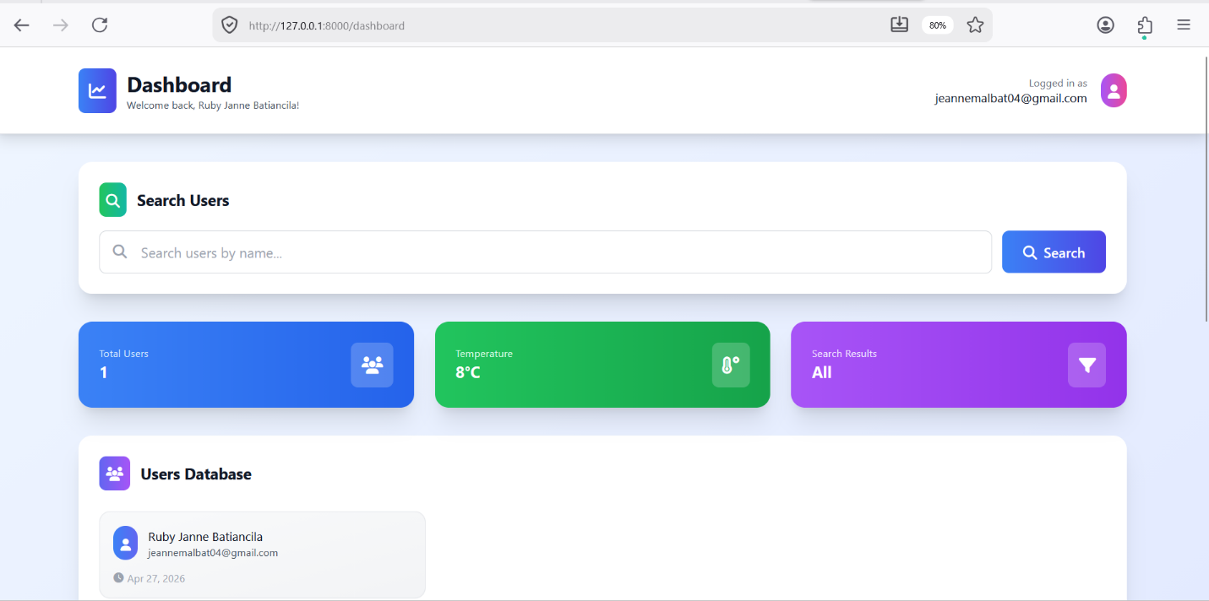
Admin Dashboard
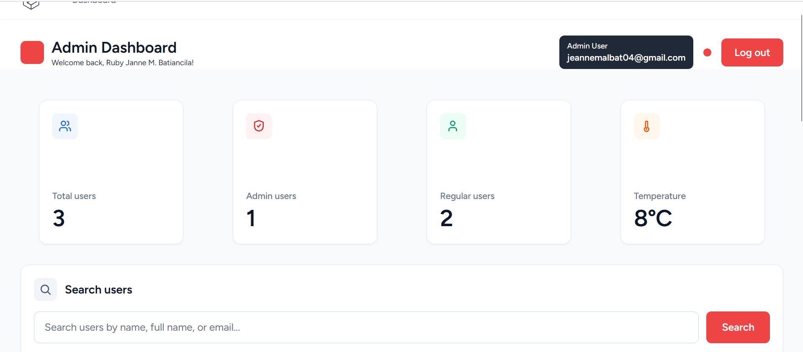
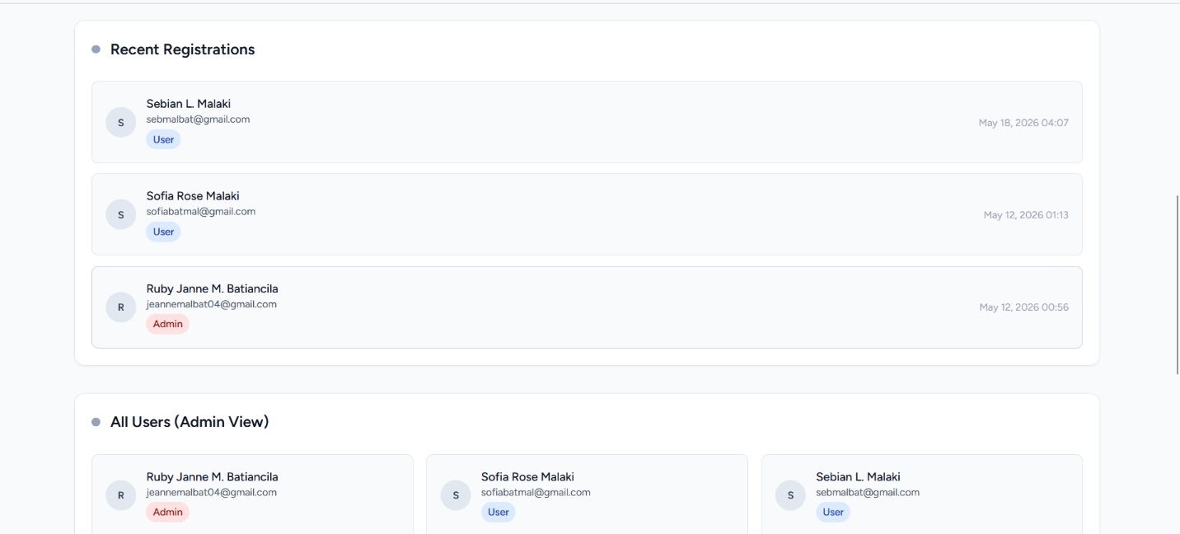

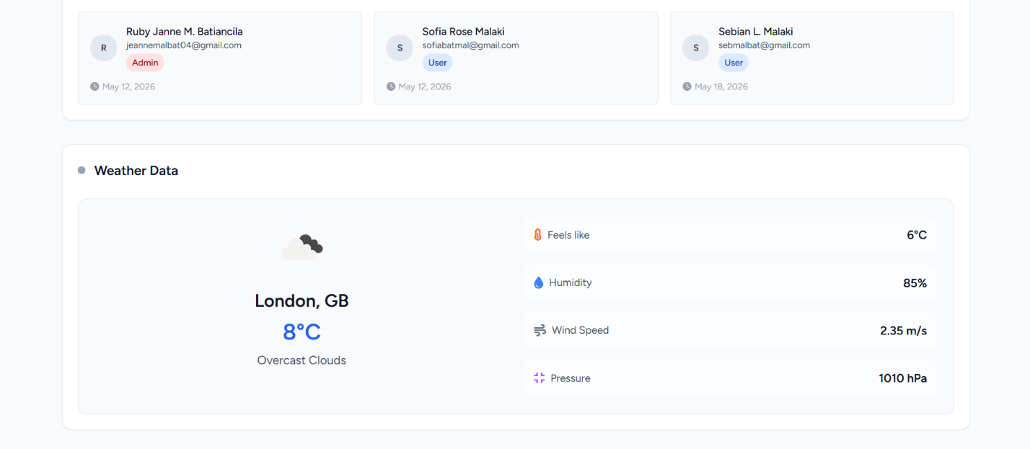
API output

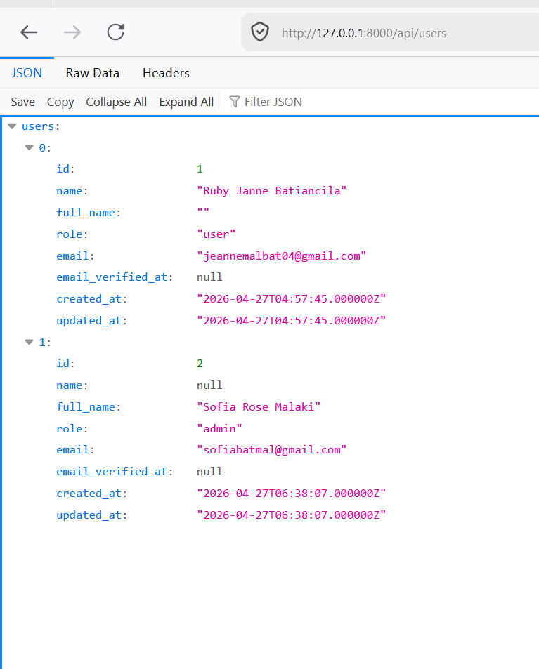

Short Documentation
System Description
The system developed is a simple web-based application built using the Laravel framework. It demonstrates the integration of authentication, internal API creation, and external API consumption within a single dashboard system.
The application allows users to register and log in securely using Laravel Breeze authentication. After logging in, users are redirected to a dashboard where they can view their profile information, a list of all registered users, and data fetched from an external API.
The main goal of the system is to demonstrate how different data sources can be combined in one interface. It provides a basic but functional example of system integration, which is commonly used in modern web applications.

APIs Used
The system uses two types of APIs:
1. Internal API (Created API)
An internal API endpoint was created to fetch user data from the database.
- Endpoint: /api/users
- Purpose: To return all registered users in JSON format
- Technology: Laravel API Route + Controller
This API demonstrates how backend data can be exposed and reused within or outside the system.

2. Public API (External API)
The system also consumes a public API from JSONPlaceholder.
- API URL: https://jsonplaceholder.typicode.com/posts
- Purpose: To fetch sample posts (title and body)
- Usage: Displayed inside the dashboard view
This shows how external data can be integrated into a Laravel application using HTTP requests.

Challenges Encountered
1. API Routing Issues
At first, the /api/users route was not working because the API routes were not properly recognized by the Laravel setup. This was solved by ensuring the correct configuration of bootstrap/app.php and properly registering the api.php file.

2. Data Integration in Dashboard
Combining three different data sources (logged-in user, internal API, and external API) required careful handling of variables and ensuring data was passed correctly from the controller to the Blade view.

3. External API Handling
Occasionally, the external API would fail or return slow responses. To handle this, error checking was implemented to prevent the system from breaking.

